# Assignment No: 2

1. **Title of Assignment:** Implement A* Algorithm for 8 puzzle game search problems.

## **Prerequisite:** Basic knowledge of Graph, Tree , informed search, uninformed search, best first search etc.

## **Objective:** In this experiment, we will be able to do the following:

* + To understand Informed Search Strategies.
  + To make use of Graph and Tree Data Structure for implementation of Informed Search strategies.
  + Study how A* Algorithm is useful for implementation of 8 puzzle game search problems

**Outcome:** Successfully able to implement 8 puzzle game search problem using A* Algorithm

## Software and Hardware Requirement:

Open Source C++ Programming tool like G++/GCC, python, Java and Ubuntu.

1. **Relevant Theory / Literature Survey:**

# Informed search

* + Informed search algorithm contains an array of knowledge such as how far we are from the goal, path cost, how to reach the goal node, etc.
  + This knowledge helps agents to explore less of the search space and find the goal node.
  + The informed search algorithm is more useful for large search spaces.
  + Informed search algorithms use the idea of heuristic, so it is also called Heuristic search

# Heuristics function:

* + Heuristic is a function which is used in Informed Search, and it finds the most promising path.
  + It takes the current state of the agent as its input and produces the estimation of how close the agent is from the goal.
  + The heuristic method, however, might not always give the best solution, but it guaranteed to find a good solution in reasonable time.
  + Heuristic function estimates how close a state is to the goal. It is represented by h(n), and it calculates the cost of an optimal path between the pair of states.
  + The value of the heuristic function is always positive.

# A* Search Algorithm:

* + A* search is the most commonly known form of best-first search.
  + It uses the heuristic function h(n), and costs to reach the node n from the start state g(n).
  + It has combined features of UCS and greedy best-first search, by which it solves the problem efficiently.
  + A* search algorithm finds the shortest path through the search space using the heuristic function.
  + This search algorithm expands less search tree and provides optimal results faster.
  + A* algorithm is similar to UCS except that it uses g(n)+h(n) instead of g(n).

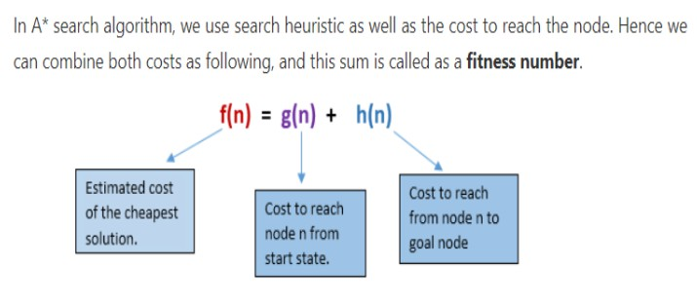

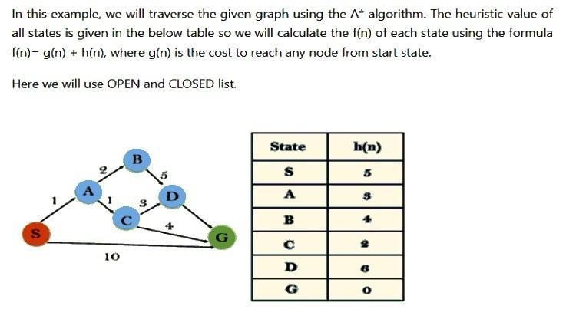

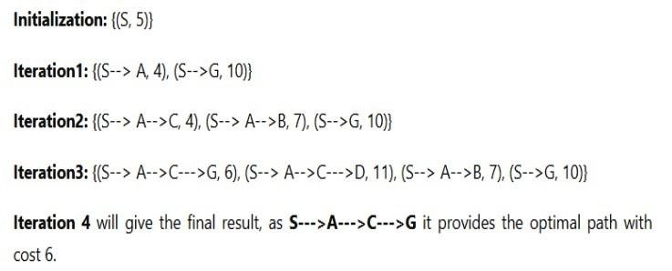

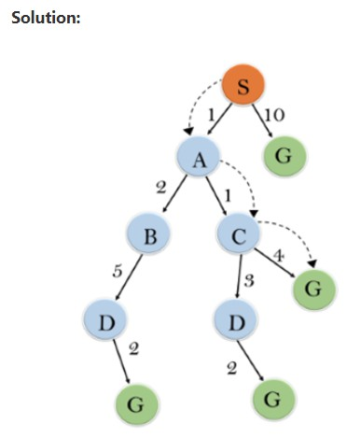

# A* search Algorithm Advantages:

* + A* search algorithm is the best algorithm than other search algorithms.
  + A* search algorithm is optimal and complete.
  + This algorithm can solve very complex problems.

# A* search Algorithm Disadvantages:

* + A* search algorithm has some complexity issues.
  + The main drawback of A* is memory requirement as it keeps all generated nodes in the memory, so it is not practical for various large-scale problems.

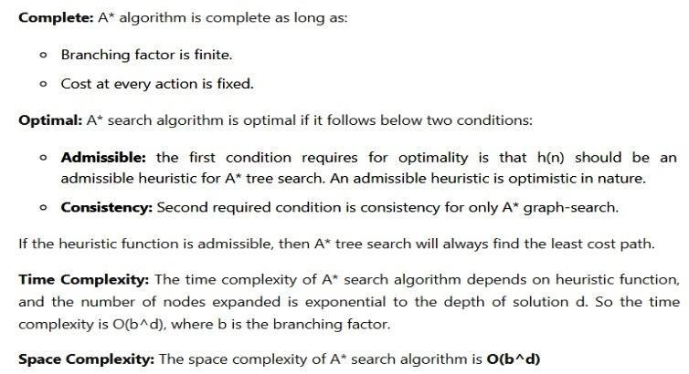

# 8 Puzzle Algorithm:-

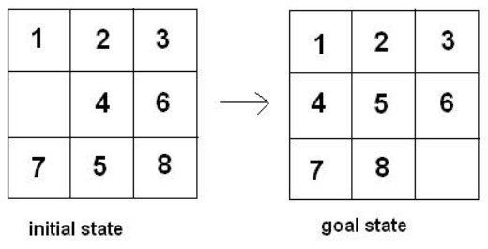The [8-puzzle problem](http://en.wikipedia.org/wiki/Fifteen_puzzle) is a puzzle invented and popularized by Noyes Palmer Chapman in the 1870s. It is played on a 3-by-3 grid with 8 square blocks labeled 1 through 8 and a blank square. Your goal is to rearrange the blocks so that they are in order. You are permitted to slide blocks horizontally or vertically into the blank square.

## There are a number of ways by which we can solve 8 puzzle problems.

* + Solution without Heuristic Function
  + Solution A* Algorithm

# Solution without Heuristic Function

## **Disadvantages**

need to explore each node and in case of failure need to generate its child which is a very time consuming as well as space consuming process.

# Solution A* Algorithm

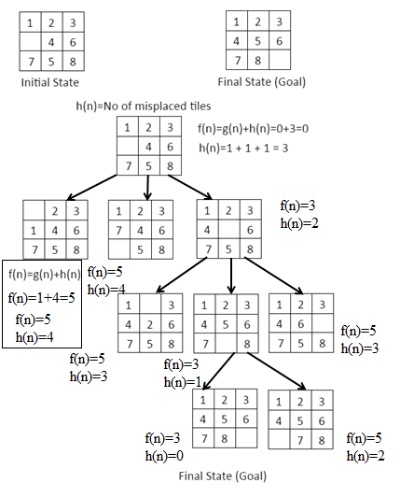

## Questions:

**Q 1:** Differentiate between Best first search and A* algorithm.

**Q 2:** Solve this problem using A* algorithm

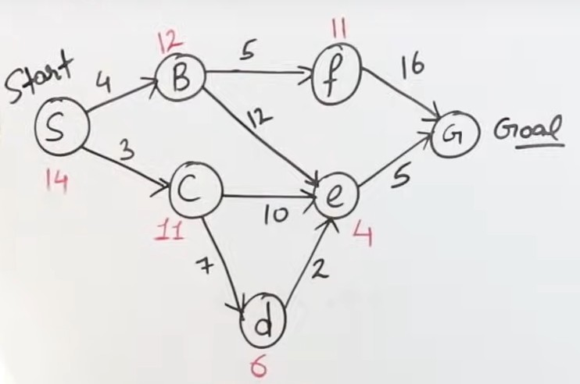

**Q 3**: What is the drawback to solve 8 Puzzle problem with a non-heuristic method?

## **Conclusion:**

In This way we have studied informed search strategy, how to calculate heuristic function and implementation of 8 puzzle game search problems using A* Algorithm.